PPL Assignment 2

NAME – Sanmeet Ramnath Wakchaure

MIS – 111903087

DIV – 2

BATCH – S1

Q1) A-1.c

C code-

int Z;

void main()

{

int a, b, c;

int p = 6;

int q;

// double r;

a = 10;

b = 20;

c = a \* b + 25;

p = 6;

q = Z;

/\* r = 34.5;

Z = r;

Z = Z + 1;

\*/

}

Objdump output-

Q2) A-2.c

C code-

int Z;

void f()

{

int a, b, c;

a = Z;

if (a < 10) {

b = 5;

c = 17;

} else {

b = 6;

c = 20;

if (a == 0) {

c = 0;

}

}

Z = b \* 10 + c;

}

Objdump output-

Q3) A-3.c

C code-

int main()

{

int sum = 0;

int i, j;

while(sum < 100) {

sum = sum \* 2;

}

for(i=0; i<25; i++) {

for(j=0; j<50; j++) {

sum = sum + i\*j;

}

}

}

Objdump output-

Q4) A-4.c

C code-

int main()

{

int a[3];

int b[] = {1, 2, 3};

int i, \*p;

for (i=0; i<3; i++) {

a[i] = b[i];

}

p = a;

\*(p + 2) = 5;

}

Objdump output-

Q5) A-5.c

C code-

int main()

{

int a, b, c, d;

d = 10;

if (c > d) {

a = 3;

b = 2;

} else {

a = 2;

b = 3;

}

c = a + b;

}

Objdump output-

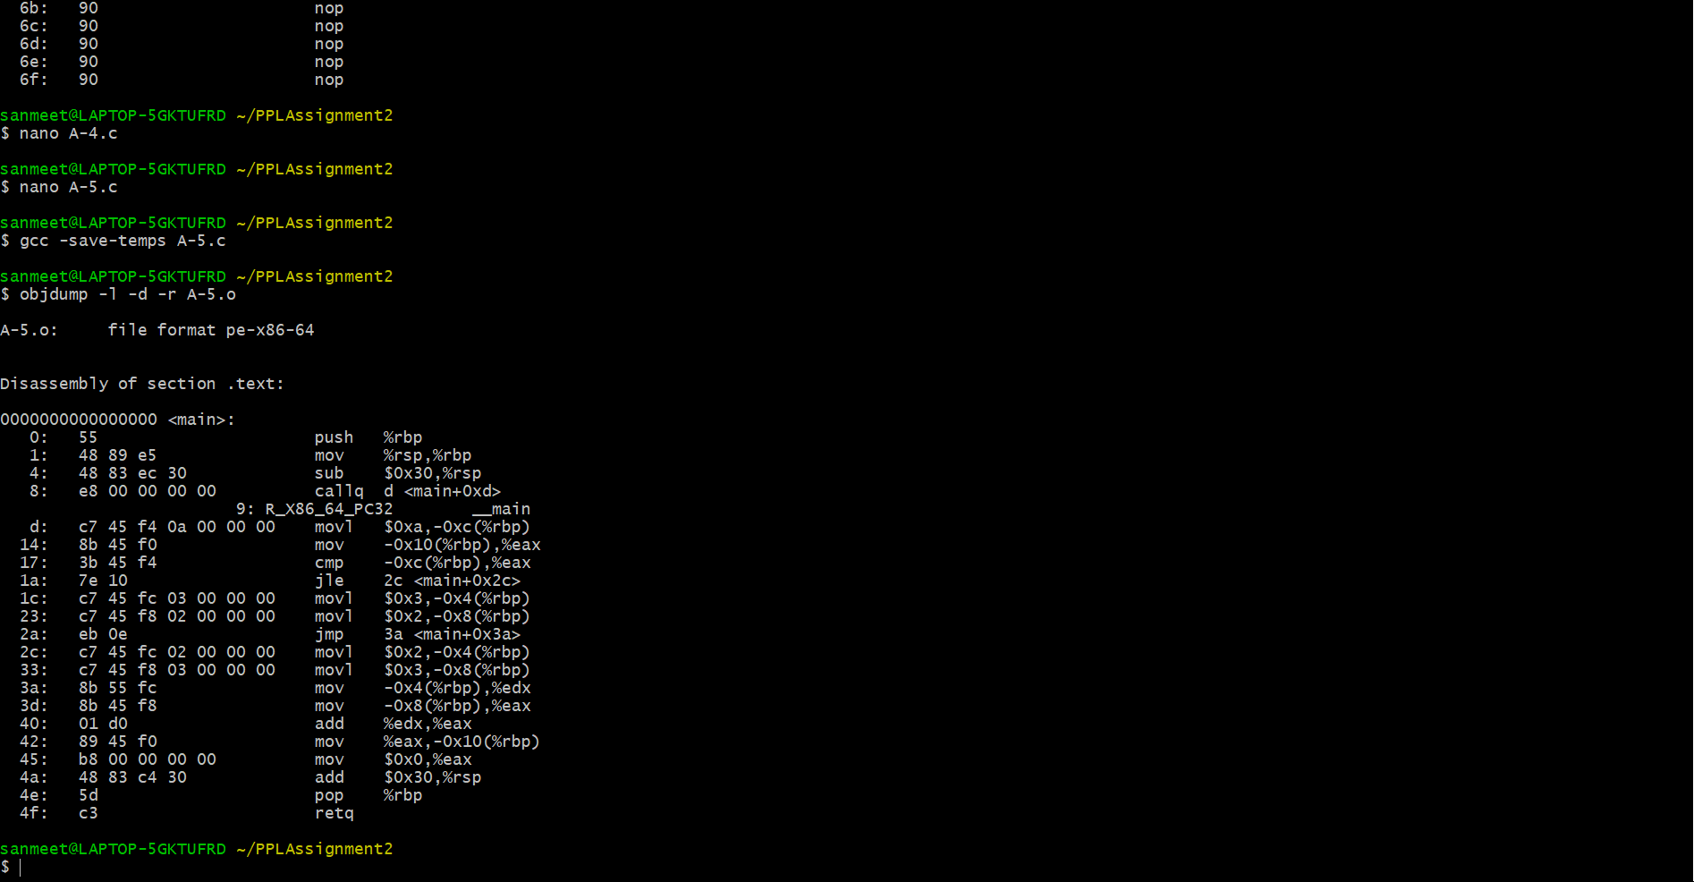

Q6) B-1.c

C code-

int AddTwo(int a)

{

a = a + 2;

return a;

}

int main()

{

int x = 3;

x = AddTwo(x);

return x;

}

Objdump output-

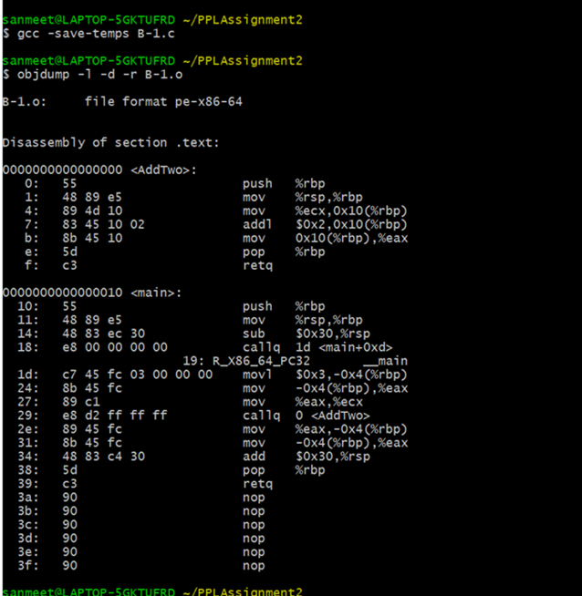

Q7) B-2.c

C code-

int N;

int main()

{

int i, a = 10;

for(i= 0; i < 4; i++)

{

a = a + N;

};

return a;

}

Objdump output-

Q8) B-3.c

C code-

#include <stdio.h>

int main ()

{

int a, b;

for (a=4 ; a<100; a++) {

if (a < 4)

b = b + 2;

else

b = b \* 2;

}

printf ("%d%d", a, b);

}

Objdump output-

Q9) B-4.c

C code-

int main()

{

int a, b, c;

b = (a + c + b) \* (c + a);

return b;

}

Objdump output-

